Scam Marshal Newsletter
May 2023
Total Scam Marshals across the UK: 2,446

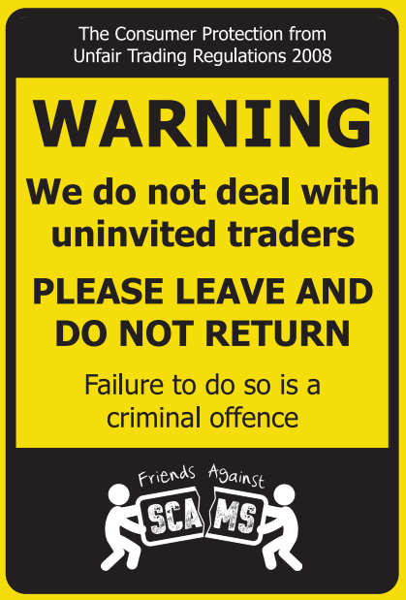
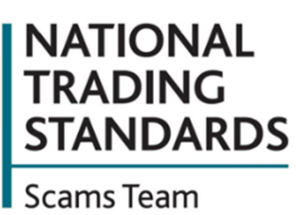
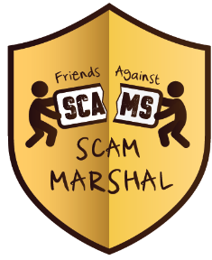
Prime Minister launches new strategy to fight criminals
The government has announced a new fraud strategy to stop scams and protect the public. Commenting on the plans, Prime Minister, Rishi Sunak, said: “Fraud now accounts for over 40% of crime. It costs us nearly £7 billion a year and we know these proceeds are funding organised crime and terror. What’s more, new technologies are making these scams easier to do and harder to police.”
New government measures will include:
- Working with Ofcom to stop ‘spoofing’, technology that allows criminals to impersonate UK numbers such as those belonging to banks, HMRC or other trusted organisations
- Banning cold calls for financial products, so that anyone who receives a call regarding an investment opportunity will know it’s a scam
To report a potential fraud, please contact Action Fraud on 0300 123 2040.

To report a potential fraud, please contact Action Fraud on 0300 123 2040.

Doorstep Criminals/Rogue Traders
Springtime regularly sees the rise of residents being targeted by cold calling criminals saying their roof, drive or gutter needs either cleaning or repair but it is a scam and they will pester the resident until they agree to them carrying out the work.
They will then carry out some extra work on a small area without asking and then demand payment and intimidate the resident into having the whole job being completed by them, even though they have not asked for this work to be carried out. Here are some steps you can take to deter the criminals:
- Consider placing a doorstep sticker on your door
- Consider the use of a video doorbell or some type of recording device at your doorstep, you can even purchase a dummy camera
Return address: FREEPOST, NTSST, MAIL MARSHALS
ADDRESS BOX


Cost of Living Payments
Payments began last week for households entitled to receive the £301 cost of living cash boost. If you are entitled to these payment’s, you will receive them automatically, so if you get an email, text or other message instructing you to apply, pay a fee or reveal confidential info, it's a SCAM.
You can forward suspicious emails to Report@phishing.gov.uk and suspicious text messages to 7726.

Fake loans

With costs rising around us, more people will be looking to take out a loan, but if you are looking for a loan, be sure to borrow from a legitimate company and be aware of criminals and their often too-good-to-be-true offers. These scams offer guaranteed loans that require you to pay an upfront fee for the loan. Once the fee has been paid, you do not hear from the criminals again and the loan is never received.

Did you know? A money lender must be authorised by the Financial Conduct Authority (FCA) to lend money legally. Those who aren’t authorised by the FCA are known as loan sharks.

Check the FCA register – online at www.fca.org.uk or by phoning 0800 111 6768.
Report a loan shark - Home – online at www.stoploansharks.co.uk or by phoning at 0300 555 2222
Top tips to avoid ticket scams
With the cost of living continuing to rise, buying theatre or sports tickets can feel like a special treat. Before you make that ticket purchase, it's important you're aware of the growing number of scams looking to target your hard-earned cash.
Here are the top tips for buying tickets safely:
- Be careful where you purchase tickets. Try to buy from the venue's box office, promoter, sports club, official agent or reputable ticket exchange websites
- Always check the sellers' privacy and returns policies before you buy.
- Don't be tempted to click on social media, text or email links or attachments offering tickets, as they could easily link to fraudulent sites.
- If you’re buying online, check the website is secure by looking for 'https' and a locked padlock in the address bar.
- In terms of payment methods, credit cards offer the best payment protection.
- Avoid paying for tickets by bank transfer, the responsibly lies solely with you and could easily result in you losing your money.
- Keep receipts until after the event.
- If you’re buying online, make sure to log out when you've completed the transaction.
- Double-check all details of your purchase before confirming payment.
Remember that ticket fraud is a crime! If you think you've been a victim of ticket fraud, report it to the Police on 101.

www.FriendsAgainstScams.org.uk

