Scam Marshal Newsletter
Summer 2026
Total Scam Marshals across the UK: 2,753

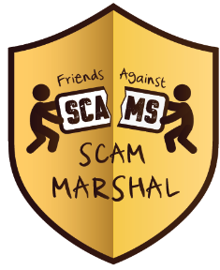
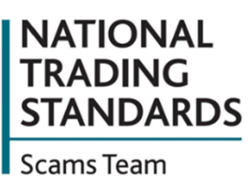
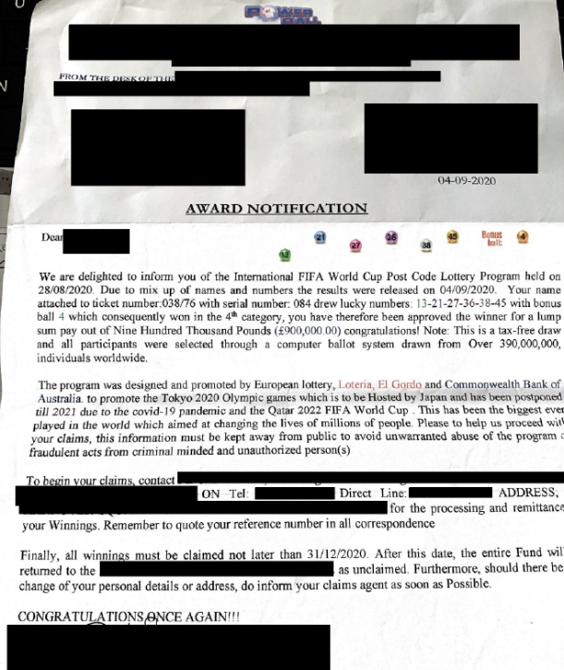
R
Welcome to your Summer Scam Marshal newsletter for 2026

Wicked World Cup Scams
With the 2026 Fifa World Cup on the horizon, criminals are using this opportunity to send mass marketing fraud letters out to people in the UK. These letters are often advertising a ‘Fifa Postcode Lottery’ claiming that the recipient has won a fortune and must pay a small amount of money to receive their winnings. They use the tactic of urgency, trying to put the victim into a hot state. They do this by giving a date that ‘winnings must be claimed by’ and stating that if this is not done by that date then the money will go back into the Lottery pot. The image on the right is an example of this scam letter from 2020.
To stay safe against these scams, always make sure to remember that no legitimate lottery will ask you to pay a fund to receive your winnings!

A note from our investigators at the National Trading Standards Scams Team
Social media has seen an increase in scams offering a variety of goods, services and similar. The types include job opportunities, prize draw and free money offers, housing disrepair, claims management for cars, finance and similar as well as offers on products and services.
If you have been a victim of this, or someone you know has, help us try and put a stop to this by sending us an email to friendsagainstscams@surreycc.gov.uk, or a letter to our freepost address (FREEPOST, NTSSST, MAIL MARSHALS) with the following information:
- What number was used to deliver the call/message
- A brief description of the suspected fraud
- What social media platform was it seen on

Return address: FREEPOST, NTSST, MAIL MARSHALS

Why have I received a password reset email I did not ask for?
Getting a password reset email you did not ask for can be worrying, but it does not always mean someone has got into your account.
It may be a simple mistake. Someone may have typed in your email address by accident. But it could also mean a criminal is checking if your email address is linked to an account.
Do not click any links in the email. Instead, go to the company’s website yourself and log in from there. Then check your account for anything unusual, such as devices you do not know, changes to your details, or messages you did not send.
If anything looks wrong, change your password straight away. Use a strong password that you do not use anywhere else. You should also turn on two factor authentication if you can.
One email may be harmless. Lots of emails should be treated as a warning sign.
Introducing Young Friends Against Scams
There is a scam out there for everyone of any age, and criminals are starting to target younger people in the UK. This has led to the Friends Against Scams team launching our Young Friends Against Scams project. It was created to help raise awareness to young people to empower them to protect themselves and their communities from scams. The project materials are designed to aid teachers and leaders of youth group organisations on this subject with information and activities set up to run a 30–60-minute session with young people aged 11+.
Resources include:
  - Main PowerPoint training
  - 30-and-60-minute lesson plans
  - Certificate and Scams Info Sheet for children & parents
  - Specialist assemblies on gaming, social media, eCommerce, romance fraud
  - Activities including a wordsearch, card game, spot the scams game
To access the materials, please visit https://www.friendsagainstscams.org.uk/young-friends on the Friends Against Scams website. Spread the word, these materials can be used by schools, groups or family members at home. Tell your local schools, groups and clubs to make sure the next generation has sufficient scam protection information.

Friends Against Scams
The National Trading Standards Scams Team raises awareness of mass marketing fraud through the Friends Against Scams initiative. Anyone can access the free online training at www.FriendsAgainstScams.org.uk or attend a face-to-face meeting organised by one of over 2,700 SCAM champion volunteers throughout the UK, and join the over 1 million friends against scams!

Report Fraud – 0300 123 2040 – www.reportfraud.police.uk
Police Scotland – 101 (from within Scotland) - www.scotland.police.uk
Citizens Advice – 0808 223 1133 – www.citizensdvice.org.uk
Citizens Advice Scotland - 0800 028 1456 - www.cas.org.uk

