Scam Marshal Newsletter
Spring 2026
Total Scam Marshals across the UK: 2,752

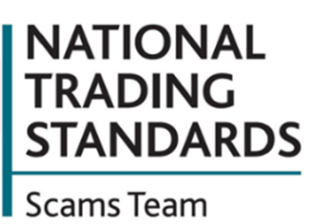
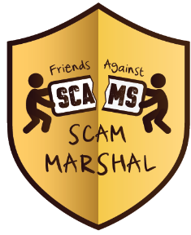
Phone Scams Take Sinister Twist as Victims’ Voices Cloned
Criminals are using AI technology to clone people’s voices and set up unauthorised direct debits over the phone. The advanced voice cloning is part of an organised criminal operation that harvests people’s personal data to target victims with a wave of scam and nuisance calls.
The process begins with a so-called ‘lifestyle survey’ phone call – seemingly harmless, but in fact designed to gather detailed personal, health and financial information. The criminals use this data to develop AI-generated voice clones used to simulate consent for direct debits, deceiving even legitimate businesses and financial providers. These details appear then to be passed or sold to other criminal operations who, with the details, can work around the banks security measures and set up payments without the victim’s knowledge. Victims often do not realise payments are being taken.
The details are revealed as new data that show that:
- On average, UK adults receive 7 scam calls or texts per month
- 1 in 5 (21%) receive scam calls or texts most days – and almost 1 in 10 (9%) receive them every day
Louise Baxter, Head of the National Trading Standards Scams Team, said:
“What we’re seeing is a deeply disturbing combination of old and new: traditional phone scams supported by disturbing new techniques. Criminals are using AI not just to deceive victims, but to trick legitimate systems into processing fraudulent payments. This is no longer just a nuisance – it’s a coordinated, sophisticated operation targeting some of the most situationally vulnerable consumers in society. We urge everyone to speak to friends and relatives about scam calls, check bank statements regularly and report anything suspicious.”
If you spot a payment or instruction you did not authorise, call your bank straight away, ask them to cancel it and raise a refund claim.
Then report it to Report Fraud immediately at reportfraud.police.uk or 0300 123 2040.

Welcome to your Spring Scam Marshal newsletter for 2026

Return address: FREEPOST, NTSST, MAIL MARSHALS
SCAM MARSHAL PANEL: The Scam Marshal Board requests you take a short amount of time to fill out this short survey on how active you are as a scam marshal, whether you would like to continue being one, and if so, if you are willing to be more proactive in the fight against scams! Scan the QR code below to complete the survey or send us a letter including your address using the FREEPOST, NTSST, MAIL MARSHALS address asking for a physical copy of the survey to be sent to you instead. You can then send your answers to us using the address above again:
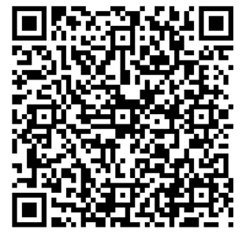
Report Fraud – 0300 123 2040 – www.reportfraud.police.uk
Police Scotland – 101 (from within Scotland) - www.scotland.police.uk
Citizens Advice – 0808 223 1133 – www.citizensdvice.org.uk
Citizens Advice Scotland - 0800 028 1456 - www.cas.org.uk

Friends Against Scams
The National Trading Standards Scams Team raises awareness of mass marketing fraud through the Friends Against Scams initiative. Anyone can access the free online training at www.FriendsAgainstScams.org.uk, or attend a face-to-face meeting organised by one of over 2,700 SCAM champion volunteers throughout the UK, and join the over 1 million friends against scams!

Here Comes the Sun… and the Opportunity for Doorstep Criminals
A Leicestershire rogue trader gang left elderly victims without roofs during winter months after charging them for shoddy building work. Four criminals defrauded victims out of more than £100,000 during their criminal endeavours which took place between 2018 and 2023 by cold calling at homes.
The gang claimed urgent building works needed doing. In most cases the work was either unnecessary or completed to a substandard level, and victims were pressured into paying immediately, either by bank transfer or by being taken to the bank to withdraw cash. These doorstep criminals take advantage of the warmer weather, so are more prevalent in the coming months.
Take these steps to protect yourself from these criminals:
- Always ask for ID if you get a knock on the door
- If you are worried, close the door and call a friend or neighbour to come to your aid
- Make sure your back door is locked – this will reduce the risk of distraction burglary
- Stay safe – If you feel in immediate danger call 999
These criminals sometimes impersonate your utility provider too. If you are worried about the legitimacy of the caller, you can always:
- Call the company using the phone number on your most recent bill

