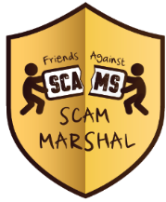
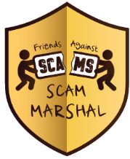
Scam Marshal Survey

Dear Scam Marshal, please find some questions below for you to answer to allow us to receive some feedback on the Scam Marshal initiative, and allow you to give us any comments/notes you would like to pass on to us here at the National Trading Standards Scams Team. Please return this page to our freepost address at the bottom of the page

- How long have you been a Scam Marshal?

- How did you hear about the Scam Marshal initiative?

- What do you do as a Scam Marshal to fight against scams?

- Would you like to do more in the fight against scams?

- If you selected yes for question 4, please tell us a bit more: what would you like to do? How can we help you with that?

- How much of a positive change has being a Scam Marshal been in your life?

- Would you like to continue as a Scam Marshal?

- Please take this opportunity to let us know anything below

Return address: FREEPOST, NTSST, MAIL MARSHALS

